

Hi, I am Ayanabha Pramanik, I have made some solutions by myself, from the exercises from this book. This document is created during my college days.

Thank you.

**Chapter 1: Getting Started**

(a) Ramesh’s basic salary is input through the keyboard. His dearness allowance is 40% of basic salary, and house rent allowance is 20% of basic salary. Write a program to calculate his gross salary.

**CODE-**

#include<stdio.h>

int main()

{

float bs,da,hra,gross;

printf("enter basic salary\n");

scanf("%f",&bs);

da=.4*bs; //dearness allowance is 40% of basic salary

hra=.2*bs; //house rentallowance is 20% of basic salary

gross=bs+da+hra;

printf("Ramesh's basic salary=%f\n",bs);

printf("Ramesh's dearness allowance is=%f\n",da);

printf("Ramesh's house rent allowance is=%f\n",hra);

printf("Ramesh's grosss salary is=%f\n",gross);

}

**OUTPUT**

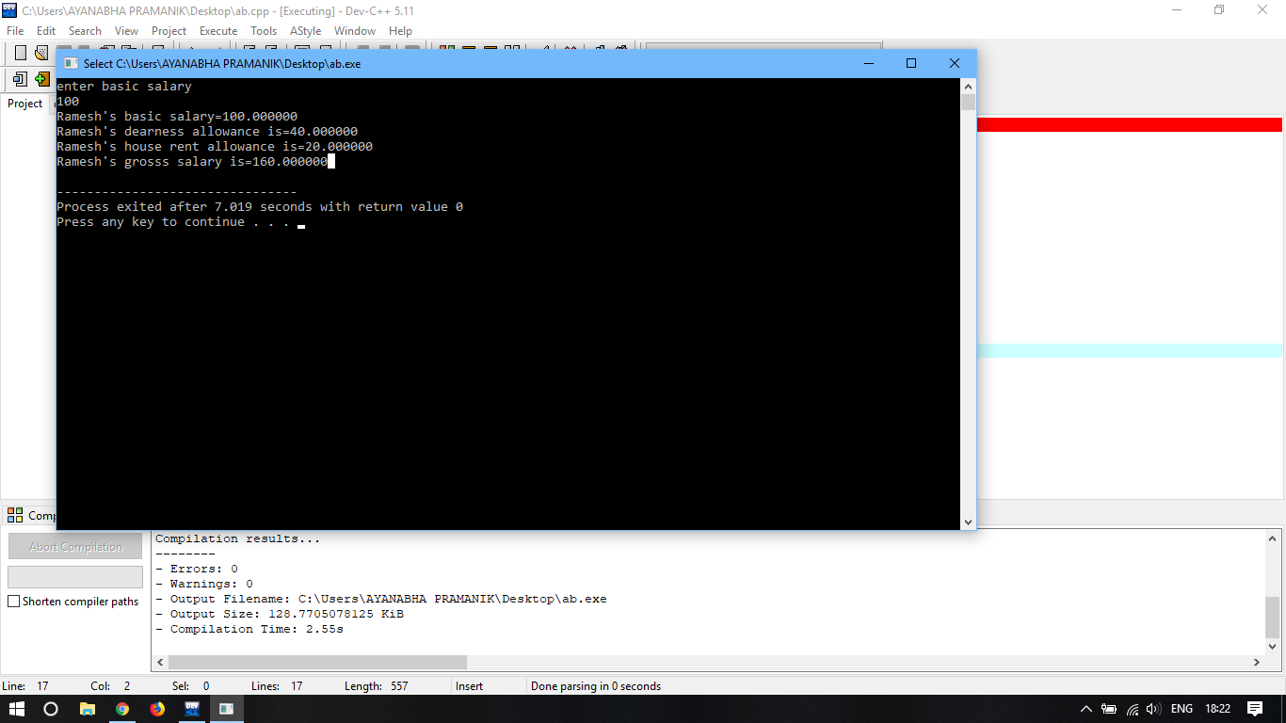

(b)

The distance between two cities (in km.) is input through a keyboard. Write a C program to convert and print this distance in meters,feet,inches and centimeters.

**CODE-**

#include<stdio.h>

int main()

{

float dist,m,f,i,cm;

printf("enter the distance between the two cities\n");

scanf("%f",&dist);

m=1000*dist;

cm=m*100;

i=cm/2.54;

f=i/12;

printf("Distance in meter=%f\n",m);

printf("Distance in centimeter=%f\n",cm);

printf("Distance in inch=%f\n",i);

printf("Distance in foot=%f\n",f);

}

**OUTPUT**

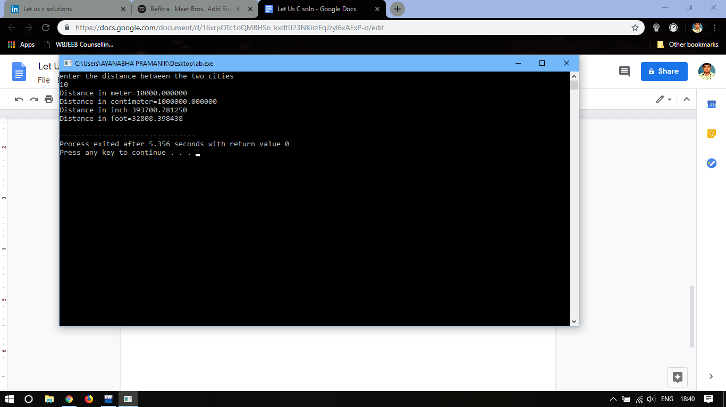

(c) If the marks obtained by a student in five different subjects are input through the keyboard, write a program to find out the aggregate marks and percentage marks obtained by the student.

**CODE-**

#include<stdio.h>

int main()

{

int a;

float ar[5];

float agg=0,per;

for(a=0;a<5;a++)

{

printf("Enter subject %d marks\n",a+1);

scanf("%f",&ar[a]);

agg=agg+ar[a];

}

printf("Aggregate marks=%f\n",agg);

per=agg/5;

printf("Percentage marks=%f",per);

}

**OUTPUT**

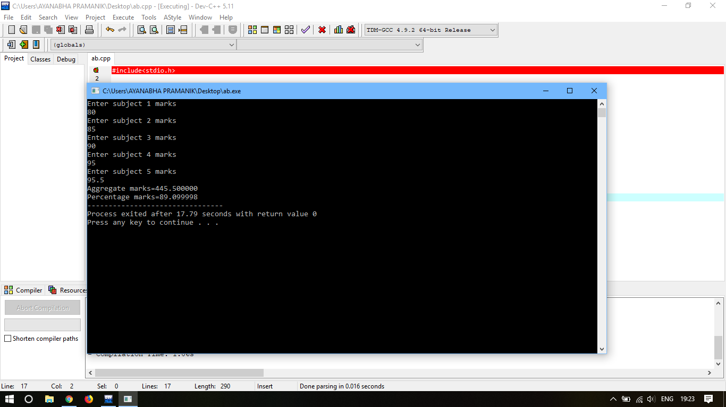

(d) Temperature of a city in Fahrenheit degrees is input through the keyboard. Write a program to convert this temperature into Centigrade degrees.

**CODE-**

#include<stdio.h>

int main()

{

float fr,cn;

printf("Enter the temperature, of the city, in fahrenheit degrees\n");

scanf("%f",&fr);

cn=(5.0/9.0)*(fr-32);

printf("Temperature in centigrade=%f",cn);

}

**OUTPUT-**

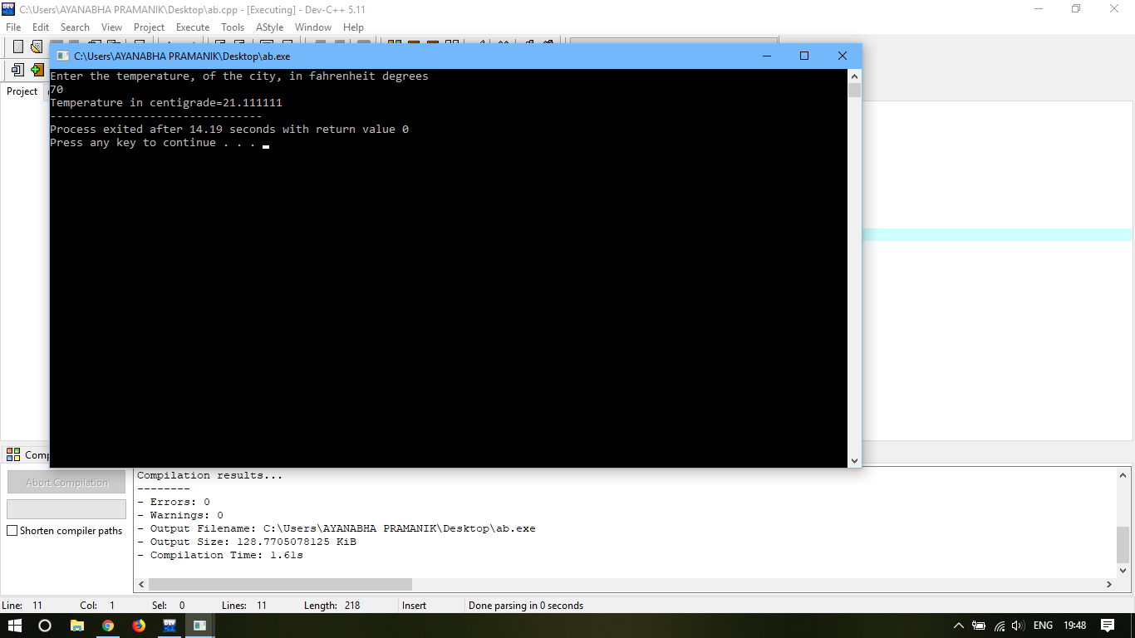

(e) The length and breadth of a rectangle and radius of a circle are input through the keyboard. Write a program to calculate the area and perimeter of the rectangle, and the area and circumference of the circle.

**CODE-**

#include<stdio.h>

int main()

{

float a,b;

float r;

float rectangle_area,rectangle_perimeter;

float circle_area,circle_circumference;

printf("Enter the length and breadth of a rectangle\n");

scanf("%f %f",&a,&b);

printf("Enter the radius of a circle\n");

scanf("%f",&r);

rectangle_area=a*b;

rectangle_perimeter=2*(a+b);

circle_area=(3.14)*r*r;

circle_circumference=2*(3.14)*r;

printf("Area of the rectangle=%f\n",rectangle_area);

printf("Perimeter of the rectangle =%f\n",rectangle_perimeter);

printf("Area of the circle=%f\n",circle_area);

printf("Perimeter of the circle=%f\n",circle_circumference);

}

**OUTPUT-**

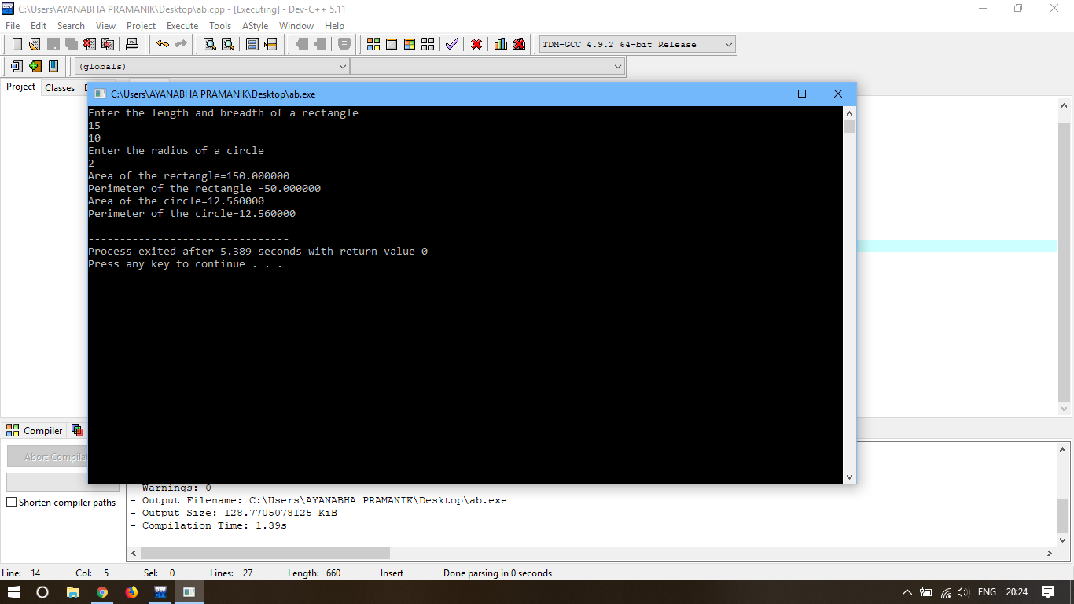

(f) Paper of size A0 has dimensions 1189 mm X 841 mm. Each subsequent size A(n) is defined as A(n-1) cut in half parallel to its shorter sides. Thus paper of size A1 would have dimensions 841 mm X 594 mm. Write a program to calculate and print paper sizes A0,A1,A2,...A8.

**CODE-**

#include<stdio.h>

int main()

{

int i;

float x,y;

x=1189;

y=841;

for (i=1;i<=8;i++)

if (x>y)

{

printf("A(%d):%f X %f\n",i,x,y);

x=x/2;

}

else if (y>x)

{

printf("A(%d):%f X %f\n",i,y,x);

y=y/2;

}

}

**OUTPUT-**

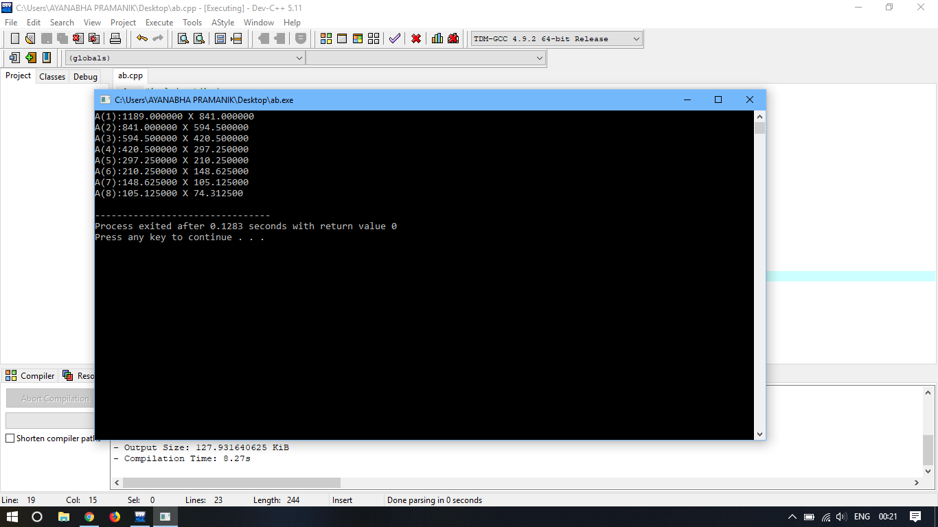

**Chapter 2: C Instructions**

(a)If a five digit number is input through the keyboard, Write a C program to calculate the sum of its digits.

**CODE-**

#include<stdio.h>

int main()

{

int input,i,sum=0;

int arr[10];

printf("Enter the number to calculate the sum of its digit");

scanf("%d",&input);

for (i=0;i<=9;i++)

{

arr[i]=input%10;

input=input/10;

sum=sum+arr[i];

}

printf("The sum of the digits of the number is=%d",sum);

}

**OUTPUT-**

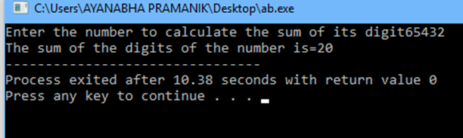

(b) If a five digit number is input through keyboard, Write a C program to reverse the number

**CODE-**

#include<stdio.h>

int main()

{

int input,i,j,output=0;

int arr[6];

printf("Enter the number \n");

scanf("%d",&input);

for(i=0;i<5;i++)

{

arr[i]=input%10;

input=input/10;

output=output*10;

output=arr[i]+output;

}

printf(“%d”,output);

}

**OUTPUT-**

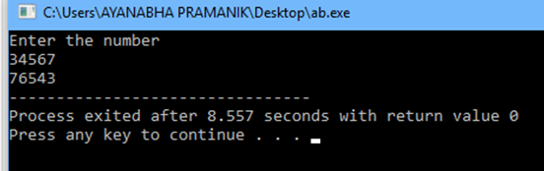

(c) If lengths of three sides of a triangle are input through the keyboard, Write a program to find the area of the triangle.

**CODE-**

#include<stdio.h>

#include<math.h>

int main()

{

float a,b,c,s;

float area;

printf("Enter the lengths of three sides of a triangle\n");

scanf("%f%f%f",&a,&b,&c);

s=a+b+c;

s=s/2;

area=s*(s-a)*(s-b)*(s-c);

area=sqrt(area);

printf("the area of the triangle is=%f\n",area);

}

**OUTPUT-**

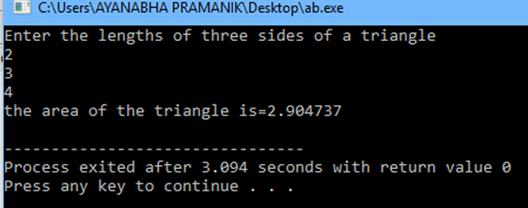

(d) Write a program to receive Cartesian co-ordinates (x,y) of a point and convert them into polar co-ordinates(r,Ɵ)

[ Hint: r= sqrt( x 2+ y2 ) and Ɵ = tan-1 (y/x) ]

**CODE-**

#include<stdio.h>

#include<math.h>

int main()

{

float x,y,r,theta;

printf("Enter the value of x and y in cartesian co-ordinates");

scanf("%f %f",&x,&y);

r=(x*x)+(y*y);

r=sqrt(r);

theta=atan2(y,x);

printf("In polar co-ordinate system r=%f,theta=%f",r,theta);

}

**OUTPUT-**

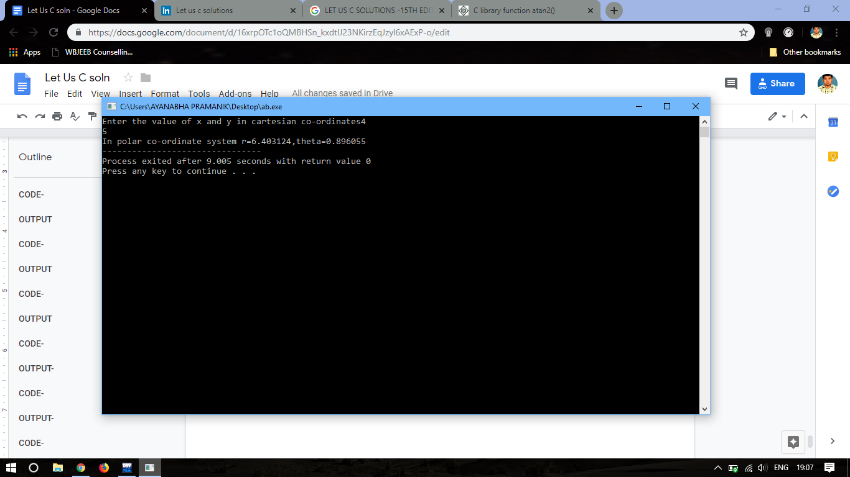

(e) Write a program to receive values of latitude (L1, L2) and longitude (G1,G2), in degrees, of two places on the earth and output the distance (D) between them in nautical miles is:

D=3963 cos-1 (sin L1 sin L2 + cos L1 cos L2 * cos ( G2 - G1 ))

**PROGRAM**

#include<stdio.h>

#include<math.h>

int main()

{

float g1,g2,l1,l2;

float D;

printf ("Enter the value of latitude and longitude, in degree, of the first place on the earth (L1,G1):\n");

scanf ("%f %f",&l1,&g1);

printf ("Enter the value of latitude and longitude, in degree, of the first place on the earth (L2,G2):\n");

scanf ("%f %f",&l2,&g2);

D=3963*acos(sin(l1)*sin(l2)+cos(l1)*cos(l2)*cos(g2-g1));

printf("The distance between this two place is :%0.3f miles",D);

return 0;

}

**OUTPUT**

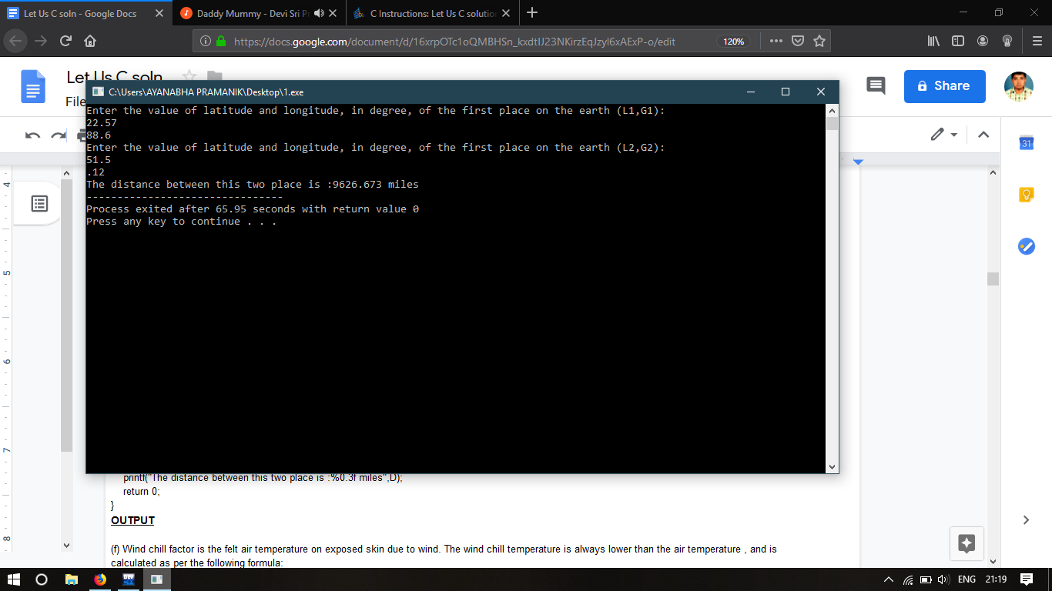

(f) Wind chill factor is the felt air temperature on exposed skin due to wind. The wind chill temperature is always lower than the air temperature, and is calculated as per the following formula:

Wcf = 35.74 + 0.6215 t + ( 0.4275 t - 35.75) * v ^ 0.16

Where t is the temperature and v is the wind velocity. Write a program to receive values of t and v and calculate wind chill factor (wcf).

**PROGRAM**

#include<stdio.h>

#include<math.h>

int main()

{

float t,v,wcf;

printf ("Enter the value of temperature:\n");

scanf ("%f",&t);

printf ("Enter the velocity of the air:\n");

scanf ("%f",&v);

wcf=35.74+(0.6215*t)+((0.4275*t-35.75)*(pow(v,0.16)));

printf("Wind chill factor =%f",wcf);

return 0;

}

**OUTPUT-**

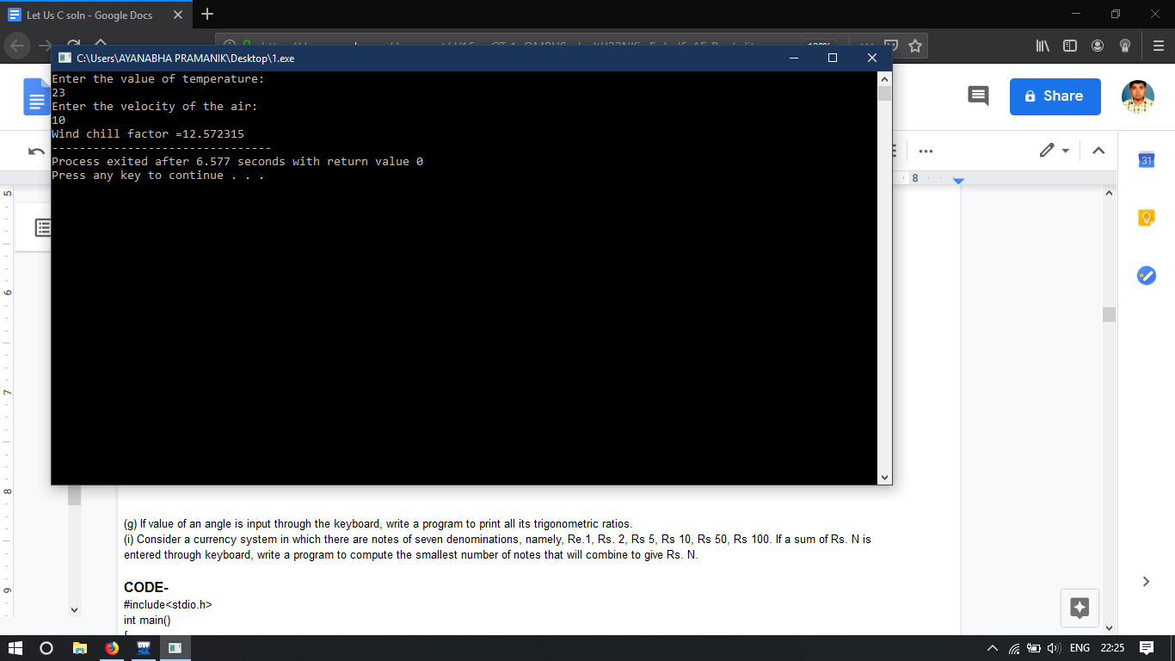

(g) If the value of an angle is input through the keyboard, write a program to print all its trigonometric ratios.

**CODE-**

#include<stdio.h>

#include<math.h>

#define PI 3.14285714

int main()

{

int angle;

float rad;

double sin_value,cos_value,tan_value;

printf("\nEnter the angle\n");

scanf("%d",&angle);

rad=PI /180;

sin_value=sin(angle*rad);

cos_value=cos(angle*rad);

tan_value=tan(angle*rad);

printf("\nsin%d=%0.2f",angle,sin_value);

printf("\ncos%d=%0.2f",angle,cos_value);

printf("\ntan%d=%0.2f",angle,tan_value);

printf("\ncosec%d=%0.2f",angle,(1/sin_value));

printf("\nsec%d=%0.2f",angle,(1/cos_value));

printf("\ncot%d=%0.2f",angle,(1/tan_value));

/*there are many limitations on this code

*/

}

**OUTPUT-**

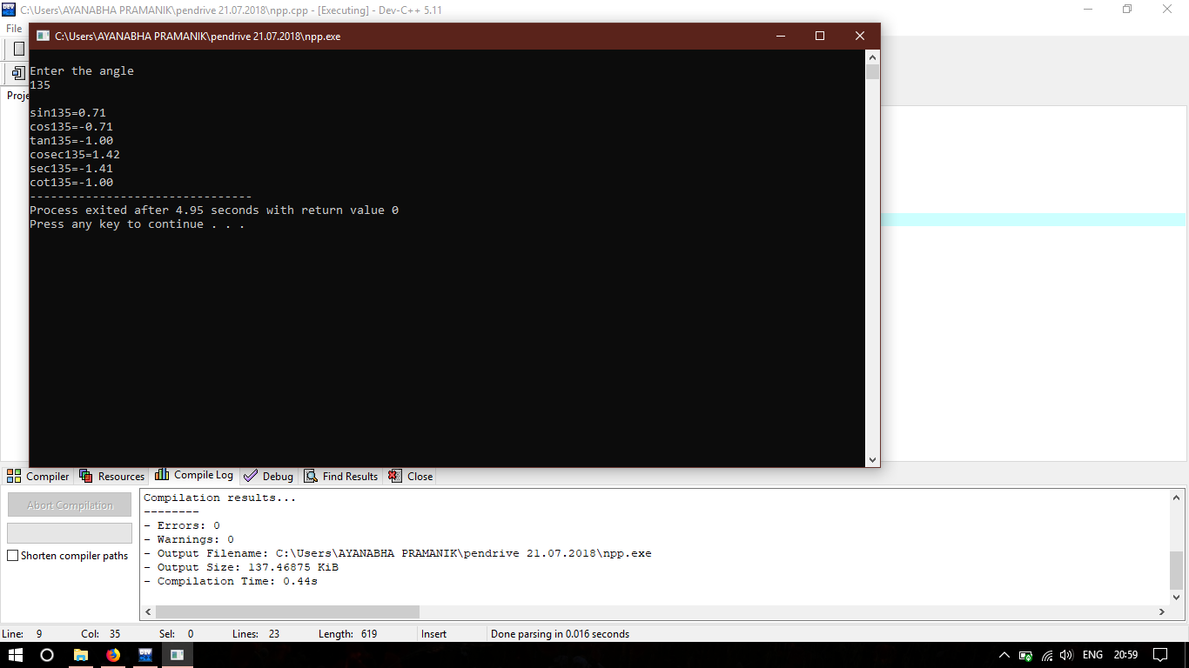

(h) Two numbers are input through the keyboard into two locations C and D. Write a program to interchange the contents of C and D.

**CODE-**

#include<stdio.h>

int main()

{

int c,d,e;

printf("\nEnter the value of C and D\n");

scanf("%d %d",&c,&d);

printf("Before swapping C= %d & D= %d\n",c,d);

e=c;

c=d;

d=e;

//this was using 3rd variable

/*without using 3rd variable

c=c+d;

d=c-d;

c=c-d;*/

//using bitwise operator

/*void swap(int*, int *);

void main()

{ int num1, num2;

printf("\nEnter two numbers:");

scanf("%d %d", &num1, &num2);

printf("\nThe numbers before swapping are Number1= %d Number2 = %d", num1, num2);

swap(&num1, &num2);

printf("\nThe numbers after swapping are Number1= %d Number2 = %d", num1, num2);

}

void swap(int *x, int *y)

{

*x = *x ^ *y;

*y = *x ^ *y;

*x = *x ^ *y;

}*/

printf("After swapping C= %d & D= %d\n",c,d);

return 0;

}

**OUTPUT-**

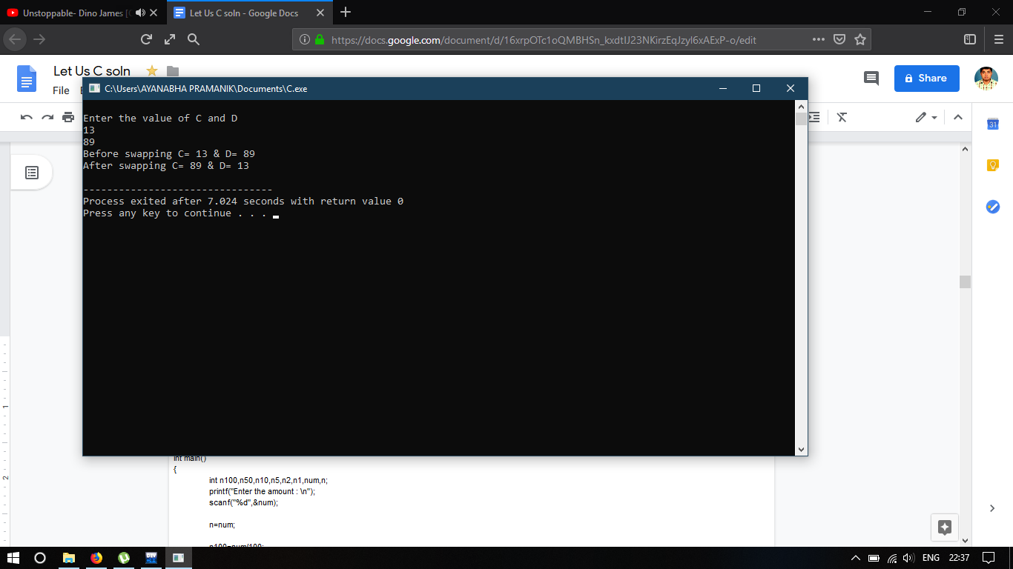

(i) Consider a currency system in which there are notes of seven denominations, namely, Re.1, Rs. 2, Rs 5, Rs 10, Rs 50, Rs 100. If a sum of Rs. N is entered through the keyboard, and write a program to compute the smallest number of notes that will combine to give Rs. N.

**CODE-**

#include<stdio.h>

int main()

{

int n100,n50,n10,n5,n2,n1,num,n;

printf("Enter the amount : \n");

scanf("%d",&num);

n=num;

n100=num/100;

num=num%100;

n50=num/50;

num=num%50;

n10=num/10;

num=num%10;

n5=num/5;

num=num%5;

n2=num/2;

num=num%2;

n1=num/1;

printf("\n\nTo give amount of %d you have to give : \n",n);

printf("%d of notes of hundred.\n", n100);

printf("%d of notes of fifty.\n", n50);

printf("%d of notes of ten.\n", n10);

printf("%d of notes of five.\n", n5);

printf("%d of notes of two.\n", n2);

printf("%d of notes of one.\n", n1);

return 0;

}

**OUTPUT-**

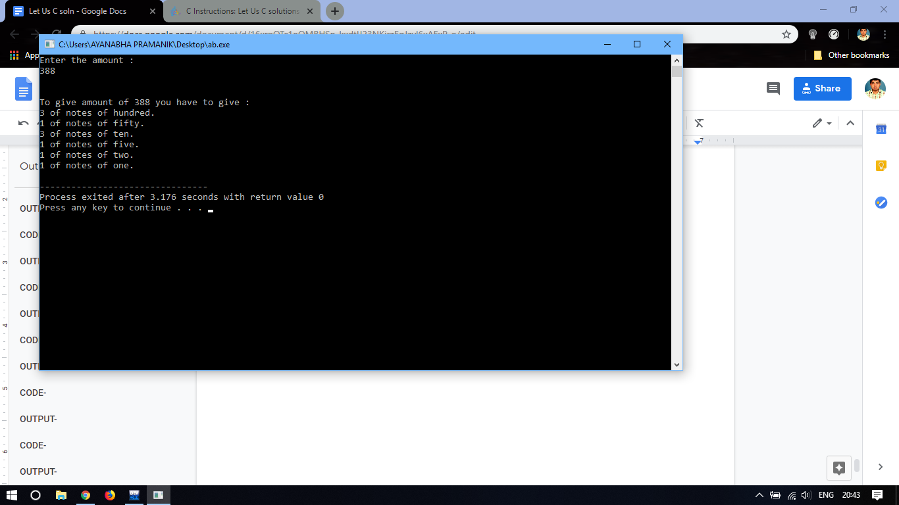

**Chapter 3: Decision Control Instruction**

1. If cost price and selling price is in put through the keyboard, write a program to determine whether the seller has made profit or incurred loss. Also determine how much profit he made or loss he incurred.

**CODE-**

#include<stdio.h>

int main()

{

float cost_price,selling_price,profit,loss;

printf("\n Enter the cost price and selling price : \n");

scanf("%f %f",&cost_price,&selling_price);

if(cost_price<=selling_price) //profit

{

printf("The seller has made profit of");

profit=selling_price-cost_price;

printf("%f\n",profit);

}

else //loss

{

loss=cost_price-selling_price;

printf("The seller has incurred loss of%f\n",loss);

}

}

**OUTPUT-**

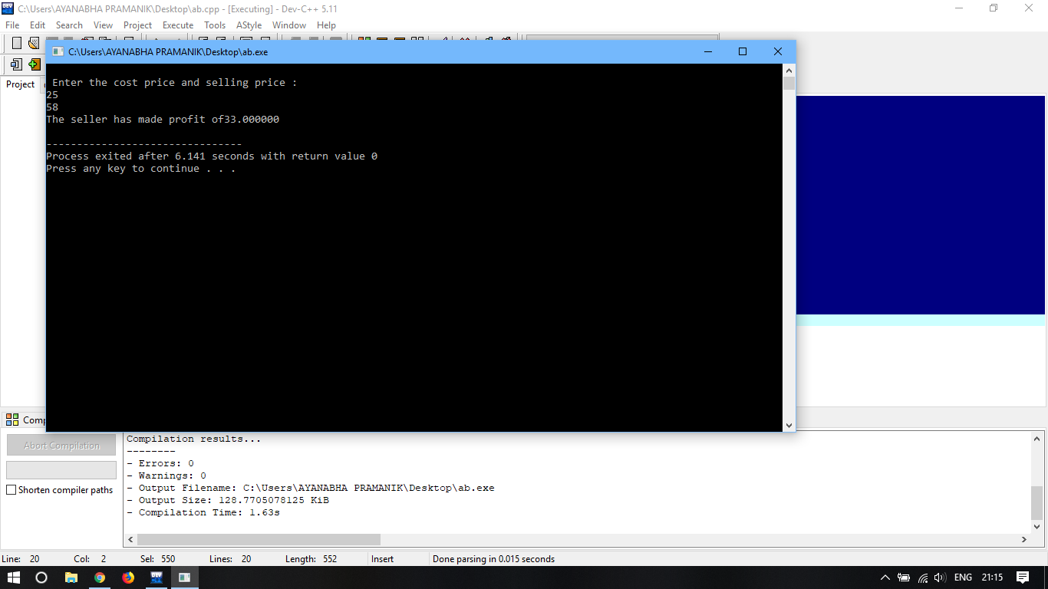

(B) Any integer is input through the keyboard. Write a program to find out whether it is an odd number or even.

**CODE-**

#include<stdio.h>

int main()

{

int n;

first:

scanf("%d",&n);

if(n%2==1)

{

printf("its a odd number");

}

else if(n%2==0)

printf("it's a even number");

goto first;

}

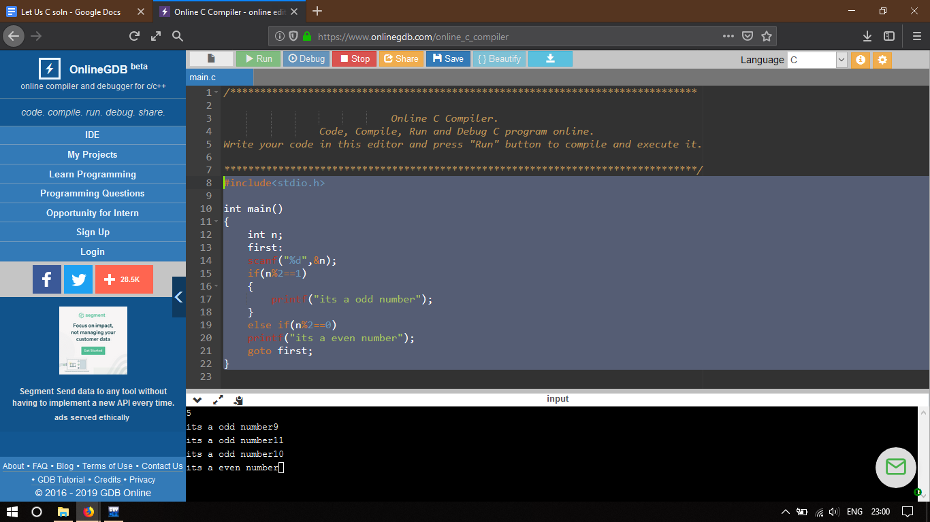

(C) Any year is input through the keyboard. Write a program to determine whether the year is leap year or not.

**CODE-**

#include<stdio.h>

int main()

{

int year;

printf("Enter a year to check if it is a leap year\n");

scanf("%d", &year);

if ( year%400 == 0)

printf("%d is a leap year.\n", year);

else if ( year%100 == 0)

printf("%d is not a leap year.\n", year);

else if ( year%4 == 0 )

printf("%d is a leap year.\n", year);

else

printf("%d is not a leap year.\n", year);

return 0;

}

**OUTPUT-**

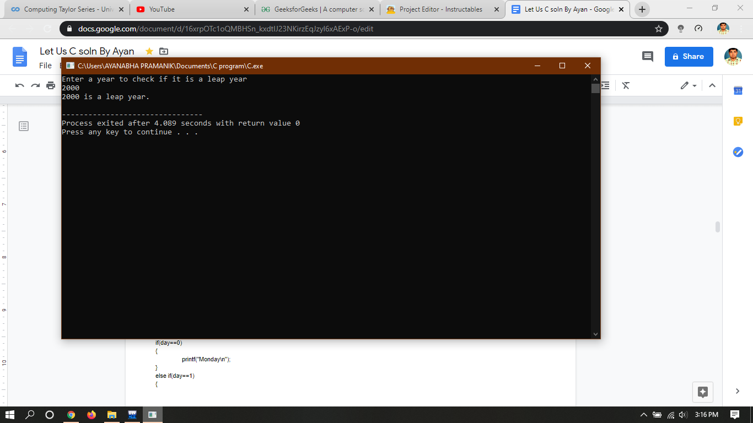

(D) According to Gregorian calender, it was Monday on the date 01/01/01. If any year is input through keyboard write a program to find out what is the day on 1st january of this year.

**CODE-**

#include<stdio.h>

int main()

{

int input_year,ref_year=2001,diff,lpyr,nmyr,total_days,day;

printf("Enter a year to determine the day of 1st january\n");

scanf("%d",&input_year);

diff=input_year-ref_year;

lpyr=diff/4;

nmyr=diff-lpyr;

total_days=(lpyr*366)+(nmyr*365);

day=total_days%7;

if(day==0)

{

printf("Monday\n");

}

else if(day==1)

{

printf("Tuesday\n");

}

else if(day==2)

{

printf("Wednesday\n");

}

else if(day==3)

{

printf("Thursday\n");

}

else if(day==4)

{

printf("Friday\n");

}

else if(day==5)

{

printf("Saturday\n");

}

else if(day==6)

{

printf("Sunday\n");

}

}

**OUTPUT-**

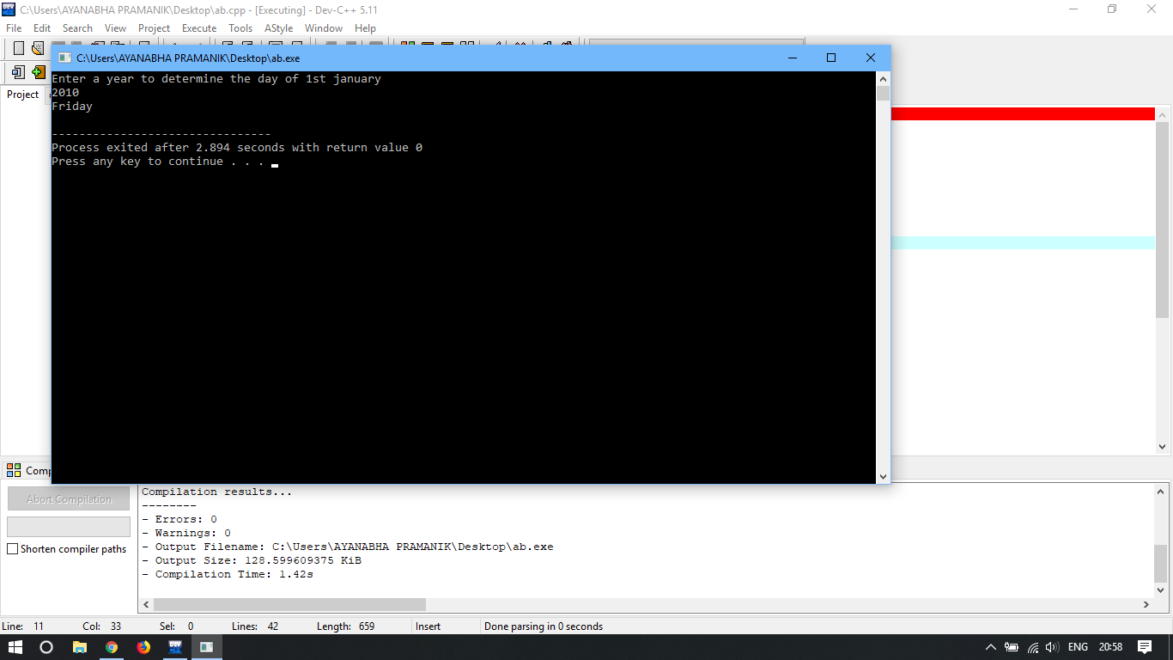

(E) A five digit number is entered through the keyboard. Write a program to obtain the reversed number and to determine whether the original and reversed numbers are equal or not.

**CODE-**

#include<stdio.h>

int main()

{

int input,i,j,output=0;

int arr[6];

printf("Enter the number \n");

scanf("%d",&input);

for(i=0;i<5;i++)

{

arr[i]=input%10;

input=input/10;

output=output*10;

output=arr[i]+output;

}

printf(“%d”,output);

if (output==input)

{

printf("\nthe original and reversed numbers are equal");

}

else

{

printf("\nthe original and reversed numbers are not equal");

}

}

**OUTPUT-**

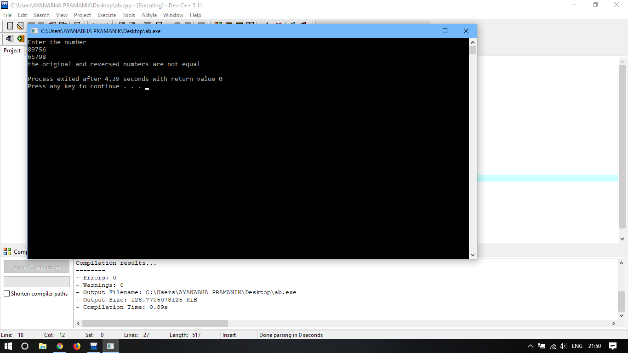

(F) If the age of Ram, Shyam, and Ajay are input through the keyboard, write a program to determine the youngest of three.

**CODE-**

#include<stdio.h>

int main()

{

int Ram,Shyam,Ajay;

printf("Enter the age of Ram, Shyam and Ajay\n");

scanf("%d %d %d",&Ram,&Shyam,&Ajay);

if(Ram<=Shyam&&Ram<=Ajay)

{

printf("Ram is younger\n");

}

else if(Shyam<=Ram&&Shyam<=Ajay)

{

printf("Shyam is younger\n");

}

else

{

printf("Ajay is younger\n");

}

}

**OUTPUT-**

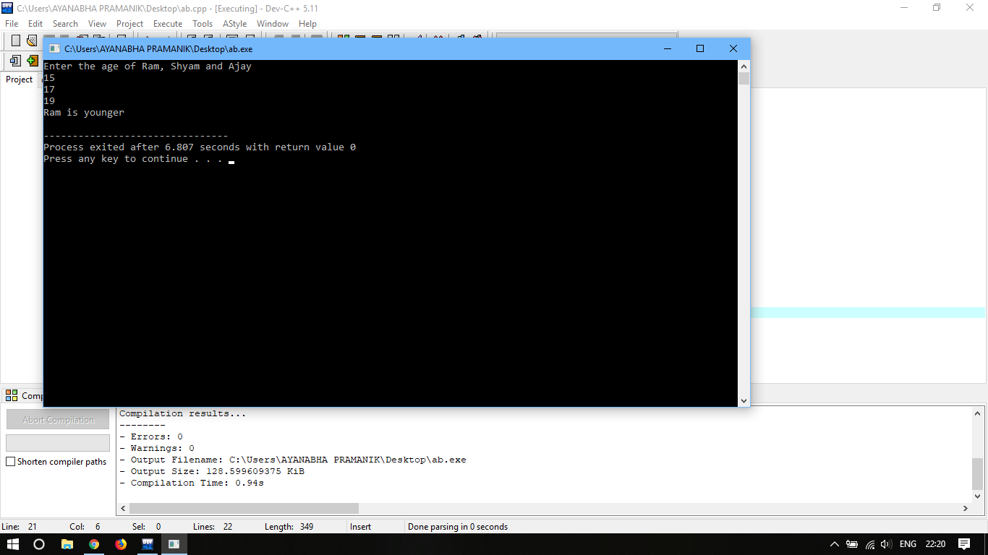

(G) Write a program to check whether a triangle is valid or not, where the three angles of the triangle are entered through the keyboard. A triangle is valid if the sum of all the three angles is equal to 180 degrees.

**CODE-**

#include<stdio.h>

int main()

{

float a,b,c;

int sum_of_angle;

first:

printf("Enter the three angle of the Triangle\n");

scanf("%f %f %f",&a,&b,&c);

sum_of_angle=a+b+c;

if(sum_of_angle==180)

printf("Its a Triangle\n");

else

printf("It's not a Triangle\n");

goto first;

}

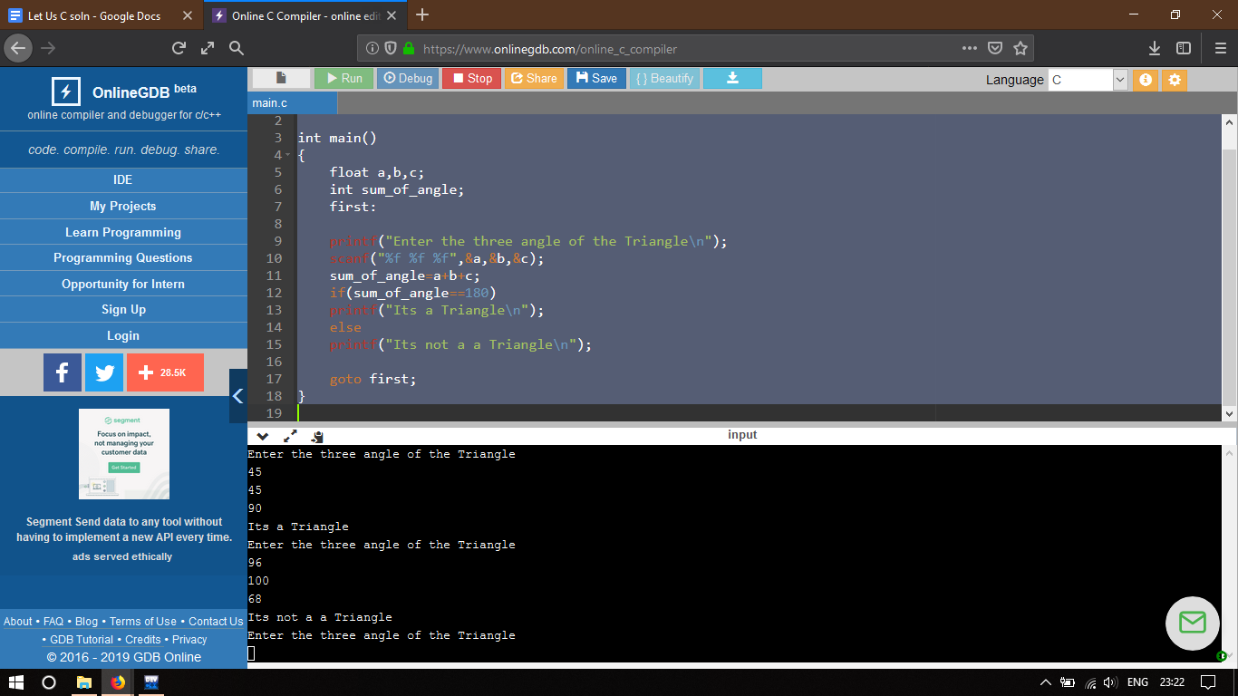

(H) Write a program to find the absolute value of a number entered through the keyboard.

**CODE-**

#include <stdio.h>

int main()

{

int n;

first:

printf ("\n Enter the number ");

scanf("%d",&n);

if (n<0)

{

n=n*(-1);

}

printf("\n The number is %u",n);

goto first;

}

**OUTPUT-**

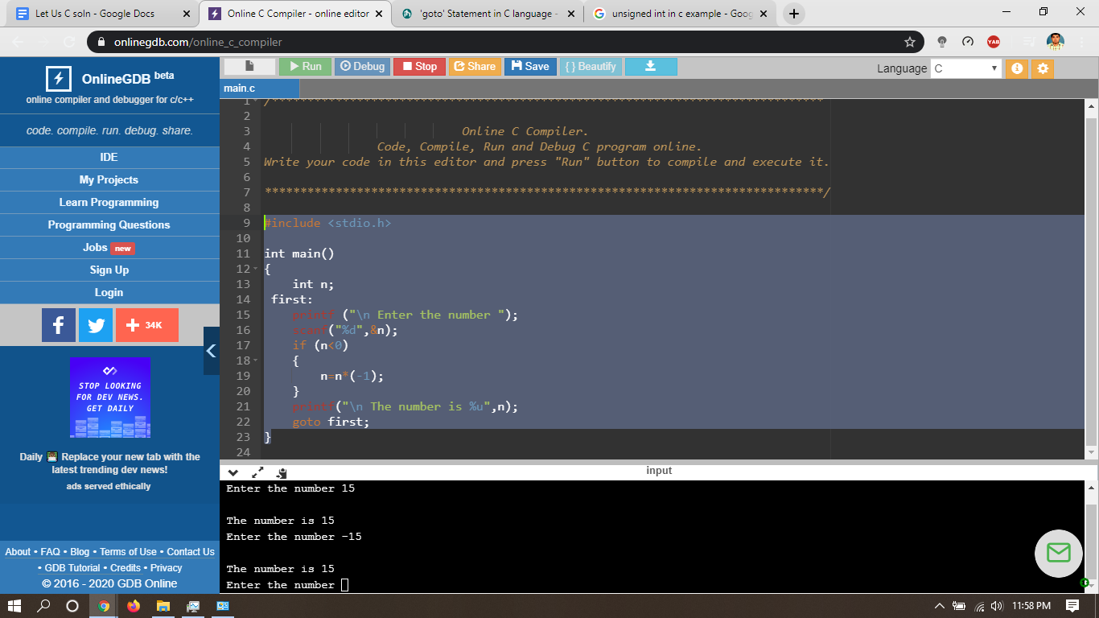

(I) Given the length and breadth of a rectangle, write a program to find whether the area of the rectangle is greater than its perimeter. For example, the area of the rectangle with length = 5 and breadth = 4 is greater than its perimeter.

**CODE-**

#include<stdio.h>

int main()

{

float length,breadth,area,perimeter;

printf("\nEnter the length and breadth of the rectangle");

scanf("%f %f",&length,&breadth);

area=length*breadth;

perimeter=2*(length+breadth);

printf("area = %f and perimter = %f",area,perimeter);

if (area>perimeter)

{

printf("\n area is greater than perimeter ");

}

else if (perimeter>area)

{

printf("\n perimeter is greater than area ");

}

else

{

printf("\n area and perimeter is equal ");

}

}

**OUTPUT-**

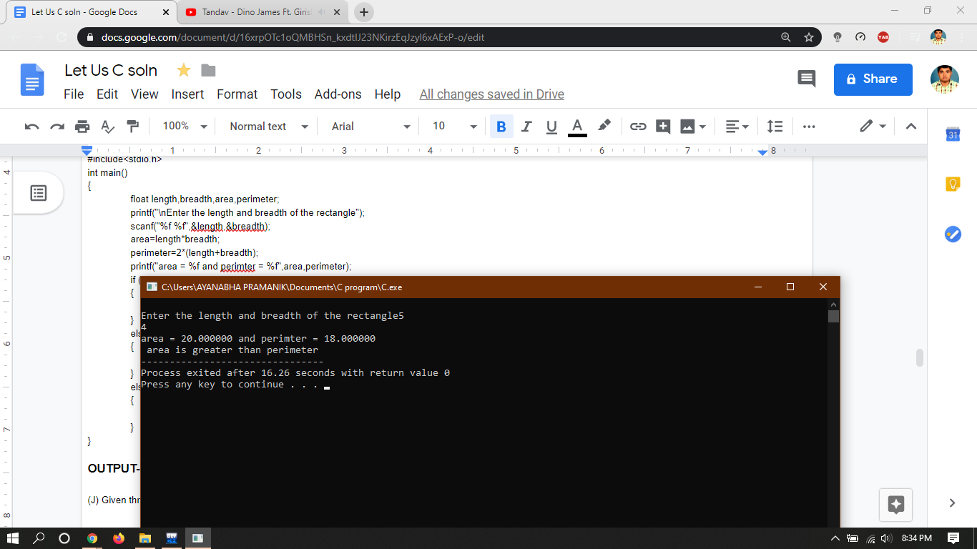

(J) Given three points (**x1,y1), (x2,y2) and (x3,y3)**, write a program to check if all the three points fall on one straight line.

**CODE-**

#include<stdio.h>

int main()

{

int x1,x2,x3,y1,y2,y3;

int m1,m2;

printf("Enter the values of (x1,y1), (x2,y2) and (x3,y3)\n");

scanf("%d %d %d %d %d %d",&x1,&y1,&x2,&y2,&x3,&y3);

m1=(y2-y1)/(x2-x1);

m2=(y3-y2)/(x3-x2);

if(m1==m2)

{

printf("\nthree points are fall on one straight line\n");

}

else

{

printf("\nthree points are not fall on one straight line\n");

}

}

**OUTPUT-**

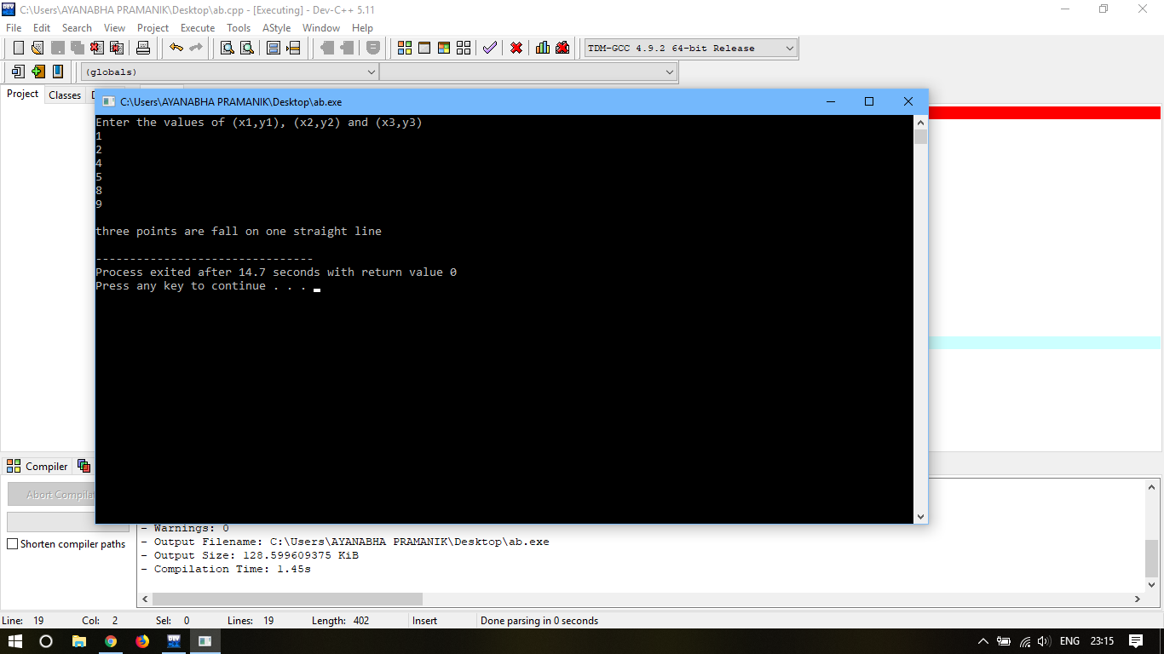

(K) Given the coordinates (**x,y**) of center of a circle and its radius, write a program that will determine whether a point lies inside the circle, on the circle or outside the circle.

**CODE-**

#include<stdio.h>

#include<math.h>

int main()

{

int x,y,x1,y1,r,p;

printf("Enter the cordinates of centre of the circle\n");

scanf("%d %d",&x,&y);

printf("Enter the radius of the circle\n");

scanf("%d",&r);

printf("Enter the co-ordinates of the point \n");

scanf("%d %d",&x1,&y1);

p=(sqrt((x1-x)*(x1-x)+(y1-y)*(y1-y)));

if(p>r)

{

printf("the point lies outside of the circle\n");

}

else if(p<r)

{

printf("the point lies inside of the circle\n");

}

else

{

printf("the point lies on the circle\n");

}

}

**OUTPUT-**

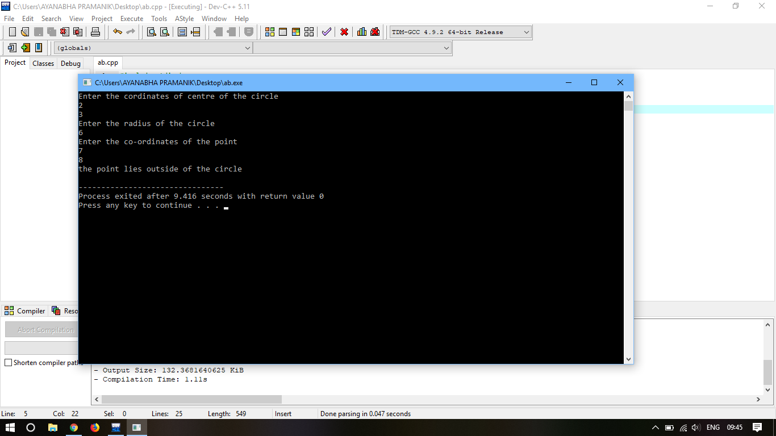

(I) Given a point (**x,y**), write a program to find out if it lies on the X-axis, Y-axis or on the origin.

**CODE-**

#include<stdio.h>

int main()

{

int x,y;

printf("Enter the co-ordinate of the point\n");

scanf("%d %d",&x,&y);

if(x==0&&y==0)

{

printf("The point lies on the origin\n");

}

else if(x!=0&&y==0)

{

printf("The point lies on X-axis\n");

}

else if(x==0&&y!=0)

{

printf("The point lies on Y-axis\n");

}

}

**OUTPUT-**

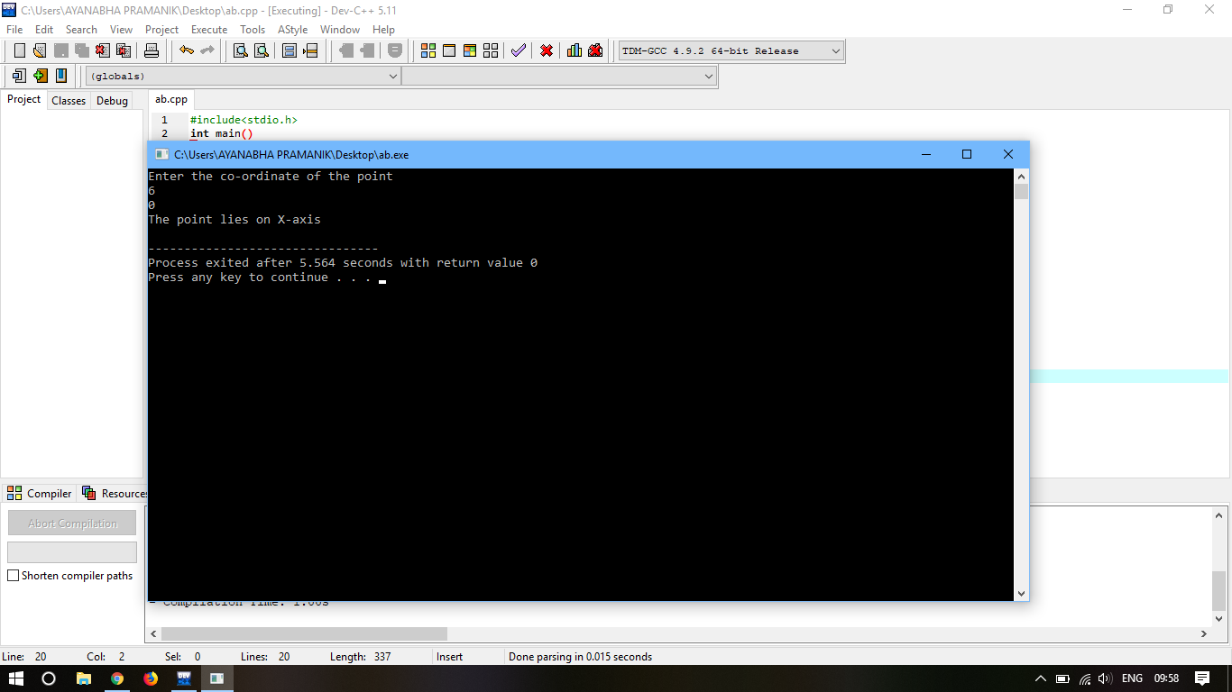

**Chapter 4: More Complex Decision Making**

1. A year is entered through keyboard, write a program to determine whether the year is leap or not.

**CODE-**

#include<stdio.h>

int main()

{

int n;

printf("\n Enter the year to check whether it is leap year or not");

scanf("%d",&n);

if(n%100==0)

{

n=n/100;

}

if (n%4==0)

{

printf("\n Its a leap year");

}

else

{

printf("\n Its not a leap year");

}

}

**OUTPUT-**

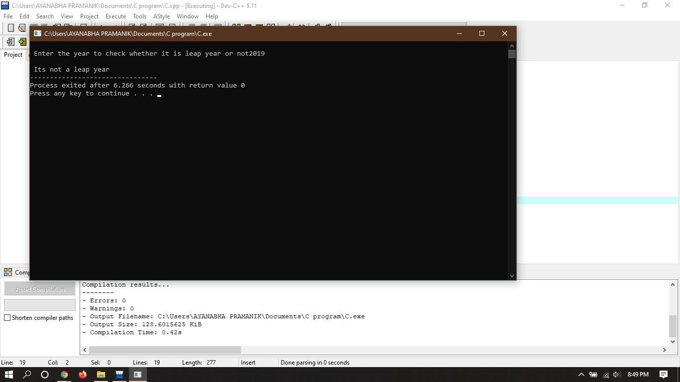

1. If a character is entered through the keyboard, write a program to determine whether the character is a capital letter, a small case letter, a digit or a special symbol.

The following table shows the range of ASCII values for various characters:

| **Characters** | **ASCII Values** |
| --- | --- |
| A-Z | 65-90 |
| a-z | 97-122 |
| 0-9 | 48-57 |
| Special symbols | 0-47, 58-64, 91-96, 123-127 |

**CODE-**

#include<stdio.h>

int main()

{

char ch;

printf("Enter a character\n");

scanf("%c",&ch);

if(ch>=65&&ch<=90)

{

printf("Upper case letter\n");

}

else if(ch>=97&&ch<=122)

{

printf("Lower case letter\n");

}

else if(ch>=48&&ch<=57)

{

printf("Digit\n");

}

else if((ch>=0 && ch<=47) || (ch>=58&& ch<=64) || (ch>=91 && ch<=96) || (ch>=123 && ch<=127))

{

printf("Special symbol\n");

}

}

**OUTPUT-**

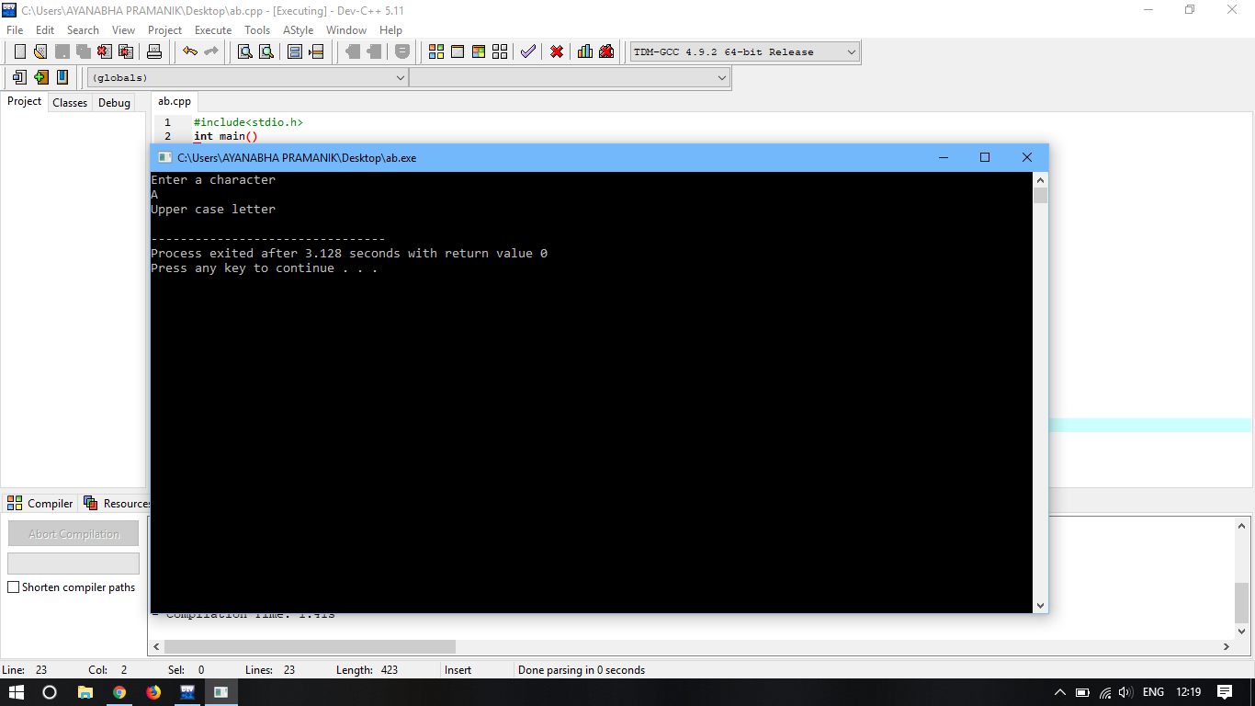

(C) If the three sides of a triangle are entered through the keyboard. Write a program to check whether the triangle is valid or not. The triangle is valid or not. The triangle is valid if the sum of two sides is greater than the largest of the three sides.

**CODE-**

#include<stdio.h>

int main()

{

int s1,s2,s3;

printf("Enter three sides of triangle: \n");

scanf("%d%d%d", &s1, &s2, &s3);

if((s1+s2)>s3)

{

if((s2+s3)>s1)

{

if((s1+s3)>s2)

{

printf("Triangle is valid.");

}

else

{

printf("Triangle is not valid.");

}

}

else

{

printf("Triangle is not valid.");

}

}

else

{

printf("Triangle is not valid.");

}

return 0;

}

}

**OUTPUT-**

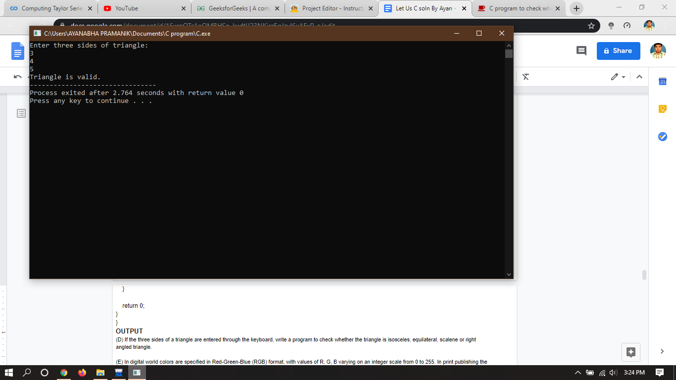

(D) If the three sides of a triangle are entered through the keyboard, write a program to check whether the triangle is isosceles, equilateral, scalene or right angled triangle.

**CODE-**

#include<stdio.h>

#include<conio.h>

#include<math.h>

int main() {

float s1, s2, s3;

printf("Enter three sides of triangle: \n");

scanf("%f%f%f", &s1, &s2, &s3);

if ((s1>=s2+s3) || (s2>=s1+s3) || (s3>=s1+s2)) {

printf("Invalid Triangle");

} else {

if ((s1==s2) && (s2==s3)) {

printf("\nThe given Triangle is equilateral\n");

} else if ((s1==s2) || (s2==s3) || (s3==s1)) {

printf("\nThe given Triangle is isoceles");

} else {

int flag=0;

if (pow(s1,2) == pow(s2,2)+pow(s3,2)) {

flag=1;

} else if (pow(s2,2) == pow(s1,2)+pow(s3,2)) {

flag=1;

} else if (pow(s3,2) == pow(s1,2)+pow(s2,2)) {

flag=1;

}

if (flag==0) {

printf("\nThe given Triangle is scalene\n");

} else {

printf("\nThe given Triangle is right angled triangle\n");

}

}

}

return 0;

}

**OUTPUT-**

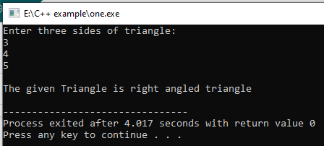

(E) In digital world colors are specified in Red-Green-Blue (RGB) format, with values of R, G, B varying on an integer scale from 0 to 255. In print publishing the colors are mentioned ig

n Cyan-Magenta-Yellow-Black (CMYK) format, with values of C, M, Y, and K varying on a real scale from 0.0 to 1.0. Write a program that converts RGB color to CMYK color as per the following formulae:

White= Max(Red/255,Green/255,Blue/255)

Cyan=(White-Red/255)/White

Magenta= (White-Green/255)/White

Yellow=(White-Blue/255)/White

Black=1-White

Note that is RGB values are all 0, then the CMY values are all 0 and the K value is 1.

**CODE-**

#include<stdio.h>

#include<conio.h>

#include<math.h>

int main() {

float red, green, blue;

printf("\nEnter the value of Red ");

scanf("%f", &red);

if (red<0 || red>255) {

printf("invalid value of Red");

return 0;

}

printf("Enter the value of Green ");

scanf("%f", &green);

if (green<0 || green>255) {

printf("invalid value of Green");

return 0;

}

printf("Enter the value of Blue ");

scanf("%f", &blue);

if (blue<0 || blue>255) {

printf("invalid value of Blue");

return 0;

}

float white=red/255;

if ((green/255)>white) {

white = green/255;

}

if ((blue/255)>white) {

white = blue/255;

}

float Cyan = ((white-(red/255))/white);

float Magneta = ((white-(green/255))/white);

float Yellow = ((white-(blue/255))/white);

float Black = 1-white;

printf("\nCyan Value: %.3f", Cyan);

printf("\nMagneta Value: %.3f", Magneta);

printf("\nYellow Value: %.3f", Yellow);

printf("\nBlack Value: %.3f", Black);

return 0;

}

**OUTPUT-**

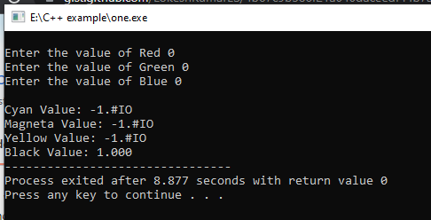

(F) A certain grade of steel is graded according to the following conditions:

i) Hardness must be greater than 50

ii) Carbon content must be less than 0.7

iii) Tensile strength must be greater than 5600

The grades are as follows:

Grade is 10 if all three conditions are met

Grade is 9 if conditions (i) and (ii) are met

Grade is 8 if conditions (ii) and (iii) are met

Grade is 7 if conditions (i) and (iii) are met

Grade is 6 if only one condition is met

Grade is 5 if none of the conditions are met

Write a program, which will require the user to give values of hardness, carbon content and tensile strength of the steel under consideration and output the grade of the steel.

**CODE-**

#include<stdio.h>

#include<conio.h>

#include<math.h>

int main() {

float hn, cc, ts;

printf("Enter the Hardness: ");

scanf("%f",&hn);

printf("Enter the Carbon Content: ");

scanf("%f",&cc);

printf("Enter the Tensile Strength: ");

scanf("%f",&ts);

int c1=0, c2=0, c3=0;

if (hn>50) {

c1++;

}

if (cc*100<70) {

c2++;

}

if (ts>5600) {

c3++;

}

if (c1 && c2 && c3) {

printf("\nSteel Grade: 10");

} else if (c1 && c2 && !c3) {

printf("\nSteel Grade: 9");

} else if (!c1 && c2 && c3) {

printf("\nSteel Grade: 8");

} else if (c1 && !c2 && c3) {

printf("\nSteel Grade: 7");

} else if (c1 || c2 || c3) {

printf("\nSteel Grade: 6");

} else if (!c1 && !c2 && !c3) {

printf("\nSteel Grade: 5");

}

return 0;

}

**OUTPUT-**

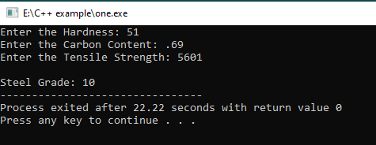

(g) The Body Mass Index(BMI) is defined as ratio of the weight of a person (in kilograms) to the square of the height (in meters). Write a program that receives weight and height, calculates the BMI, and reports the BMI category as per the following table:

| BMI Category | BMI |
| --- | --- |
| Starvation | <15 |
| Anorexic | 15.1 to 17.5 |
| Underweight | 17.6 to 18.5 |
| Ideal | 18.6 to 24.9 |
| Overweight | 25 to 25.9 |
| Obese | 30 to 30.9 |
| Morbidly Obese | >= 40 |

**CODE-**

#include<stdio.h>

#include<conio.h>

#include<math.h>

int main() {

float weight, height;

printf("Enter the weight of the person(in kilograms): ");

scanf("%f", &weight);

printf("Enter the height of the person(in meters): ");

scanf("%f", &height);

float bmi=0;

bmi = weight / (height * height);

printf("\nRate rate: %f",bmi);

if ((bmi*10)<150) {

printf("\nBMI Category: Starvation");

} else if (((bmi*10)>=151) && ((bmi*10)<=175)){

printf("\nBMI Category: Anorexic");

} else if (((bmi*10)>=176) && ((bmi*10)<=185)) {

printf("\nBMI Category: Underweight");

} else if (((bmi*10)>=186) && ((bmi*10)<=249)) {

printf("\nBMI Category: Ideal");

} else if (((bmi*10)>=250) && (bmi*10)<=259) {

printf("\nBMI Category: Overweight");

} else if (((bmi*10)>=300) && (bmi*10)<=309) {

printf("\nBMI Category: Obese");

} else if ((bmi*10)>=400) {

printf("\nBMI Category: Morbidly Obese");

}

return 0;

}

**OUTPUT-**

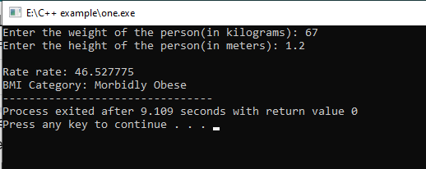

**Chapter 5: Loop Control Instruction**

1. Write a program to calculate overtime pay of 10 employees. Overtime is paid at the rate of Rs. 12.00 per hour for every hour worked over 40 hours. Assume that employees do not work for fractional part of an hour.

**CODE-**

#include<stdio.h>

int main()

{

int i=0,work_time,over_time,overtime_pay=0;

while(i<10)

{

printf("\nEnter work time of employee %d in hour\n",i+1);

scanf("%d",&work_time);

if(work_time>40)

{

over_time=work_time-40;

overtime_pay=overtime_pay+(over_time*12);

}

i++;

}

printf("\nTotal overtime pay=%d\n",overtime_pay);

}

**OUTPUT-**

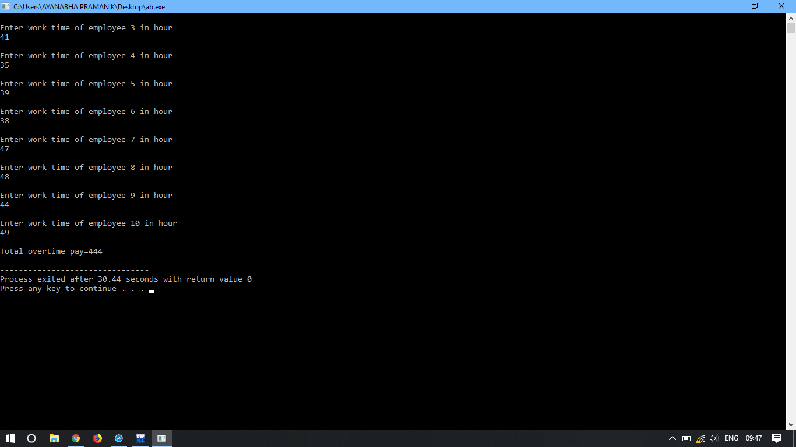

(B) Write a program to find the factorial value of any number entered through keyboard.

**Code-**

#include<stdio.h>

#include<conio.h>

#include<math.h>

int main() {

int i, n=0, fact=1;

printf("Enter the number to calculate factorial: ");

scanf("%d",&n);

for (i=1; i<=n; i++) {

fact *= i;

}

printf("Factorial of %d: %d", n, fact);

return 0;

}

**Output-**

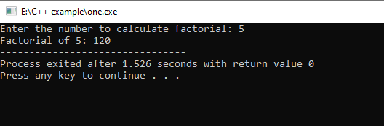

(C) Two numbers are entered through the keyboard. Write a program to find the value of one number raised to the power of another.

**CODE-**

#include<stdio.h>

int main()

{

int no1,no2,i=0,ans=1;

printf("\n Enter two number\n");

scanf("%d %d",&no1,&no2);

while(i<no2)

{

ans=ans*no1;

i++;

}

printf("\n%d is raised to %d is %d\n",no1,no2,ans);

}

**Output-**

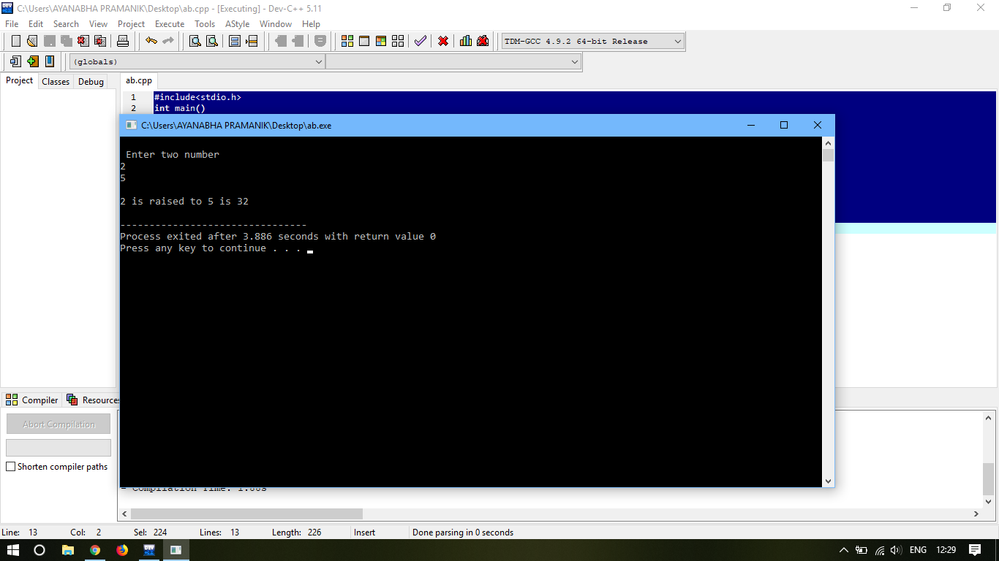

(d) Write a program to print all the ASCII values and their equivalent characters using a while loop. The ASCII values from 0 to 255.

**PROGRAM**

#include<stdio.h>

#include<conio.h>

#include<math.h>

int main() {

int n=0;

while(n<=255) {

printf("%c ",n);

n++;

}

return 0;

}

**OUTPUT**

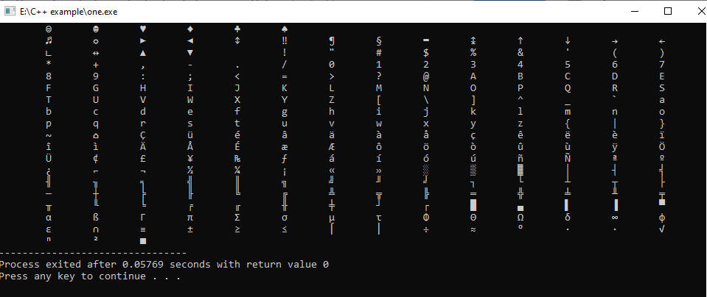

(e) Write a C program to print out all armstrong numbers between 1 and 500. If sum of the cubes of each digit of the number is equal to the number itself, then the number is called an armstrong number. For example , 153 = (1*1*1)+(5*5*5)+(3*3*3).

**Program-**

#include<stdio.h>

int armstrong(int);

int main()

{

int n=1,a;

printf("The armstrong numbers from 1 to 500:\n");

while (n<=500)

{

a=armstrong(n);

if(a!=0)

printf("%d\t",a);

n++;

}

// armstrong(n);

return (0);

}

int armstrong(int n)

{

int digit1,digit2,digit3,arm,num;

num=n;

digit1=n%10;

digit2=(n/10);

digit2=(digit2%10);

digit3=(n/100);

arm=(digit1*digit1*digit1)+(digit2*digit2*digit2)+(digit3*digit3*digit3);

if(arm==num)

{

return arm;

}

else

{

return 0;

}

// printf("%d %d %d",digit1,digit2,digit3);

}

**Output**

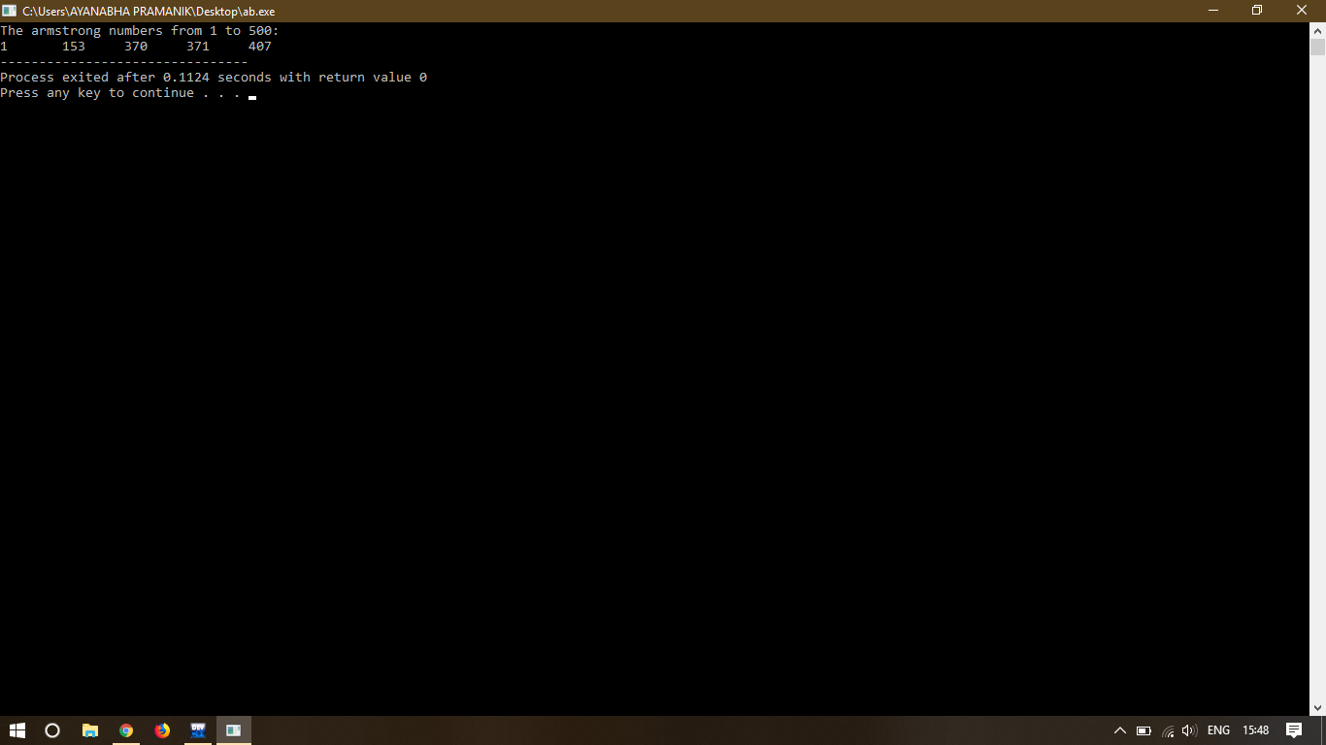

(f) Write a program for a matchstick game being played between the computer and a user. Your program should ensure that the computer always wins. Rules for the game are as follows:

- These are 21 matchsticks.

- The computer asks the player to pick 1, 2, 3 and 4 matchsticks.

- After the person picks, the computer does its picking.

- Whoever is forced to pick up the last matchstick loses the game.

**Code-**

#include<stdio.h>

#include<conio.h>

#include<math.h>

int main() {

int matchsticks=21, user, computer;

printf("Do not enter Invalid Numbers. \nNumbers above 4 are invalid.");

printf("\nIf you do so, the computer automatically wins.");

while (matchsticks>=1) {

printf("\nNumber of matchsticks available right now is %d.", matchsticks);

printf("\n\nYour Turn...\n\n");

printf("\nPick up the matchstick(s)-- (1-4): ");

scanf("%d",&user);

if (user>4 || user<1) {

printf("Invalid Selection");

break;

}

computer = 5-user;

printf("\nComputer's Turn.. \n\n");

printf("\nComputer chooses: %d", computer);

matchsticks = matchsticks-user-computer;

//continue;

if (matchsticks == 1) {

break;

}

}

matchsticks--;

printf("\nComputer Wins");

return 0;

}

**Output-**

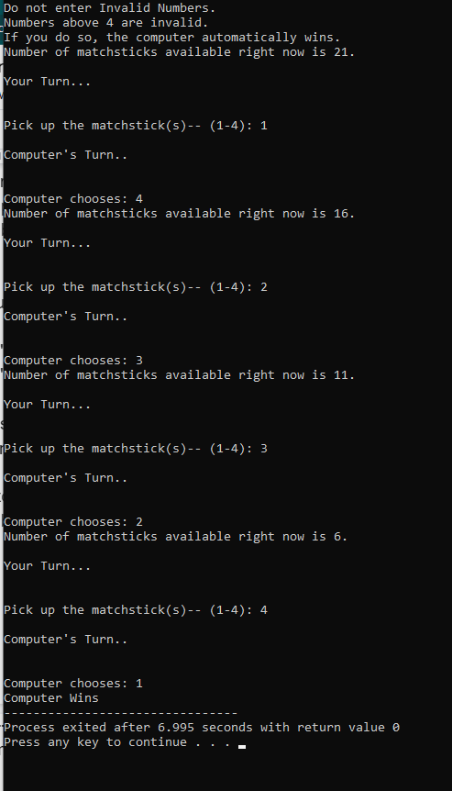

(g) write a program to enter numbers till user wants. At the end it should display the count of positive, negative and zeros entered.

**Program**

#include<stdio.h>

int main()

{

int n,positive=0,negative=0,zero=0;

char choice;

do

{

printf("Enter a number\n");

scanf("%d",&n);

if(n>0)

{positive++;}

else if(n<0)

{negative++;}

else if(n==0)

{zero++;}

printf("Do you want to continue Y/N? \n");

scanf("%c", &choice);

choice=getche();

}while(choice=='y'||choice=='Y');

printf("positive numbers=%d \n negative numbers=%d \n zero=%d \n",positive,negative,zero);

return 0;

}

**Output-**

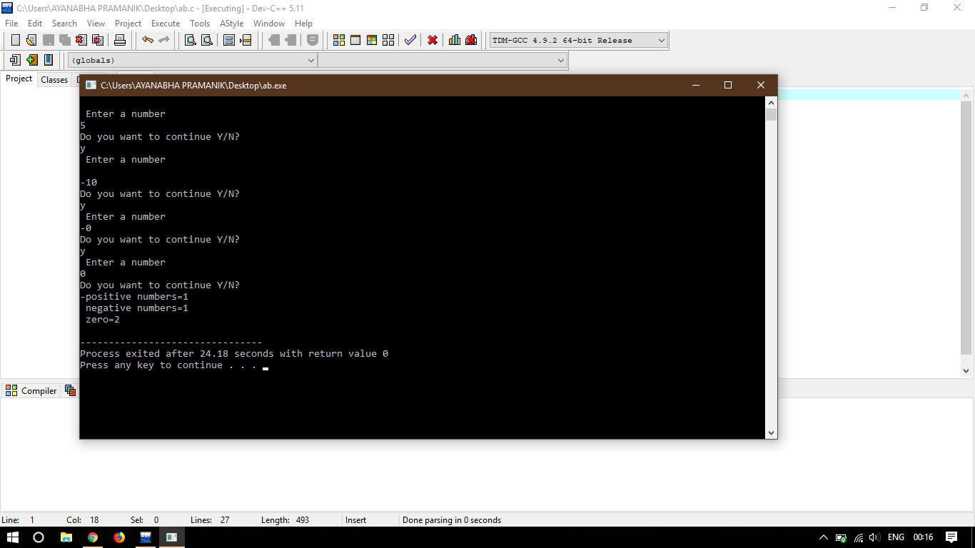

(h) Write a program to receive an integer and find its octal equivalent.

(Hint: To obtain octal equivalent of an integer, divide it continuously by 8 till dividend doesn’t become zero, then write the remainders obtained in reverse direction. )

**Program-**

#include<stdio.h>

#include<conio.h>

#include<math.h>

int main() {

int n, oct=0, rem=0;

int temp;

printf("Enter a number ");

scanf("%d", &n);

temp = n;

while (temp>0) {

rem = temp % 10;

oct = (oct*10) + rem;

temp = temp / 10;

}

printf("\nOctal equivalent of %d is: %d", n, oct);

return 0;

}

**Output-**

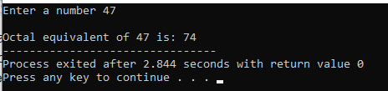

(i) Write a program to find the range of a set of numbers entered through the keyboard. Range is difference between the smallest and biggest number.

**Program-**

#include<stdio.h>

int main()

{

int i,n,arr[100],large=-30000,small=30000;

printf("Enter the size of the set\n");

scanf("%d",&n);

printf("Enter the numbers of the set\n");

for(i=1;i<=n;i++)

{

scanf("%d",&arr[i]);

if(arr[i]>large)

large=arr[i];

if(arr[i]<small)

small=arr[i];

}

printf("The largest number among the set is %d \n and The smallest number among the set is %d",large,small);

}

**Output-**

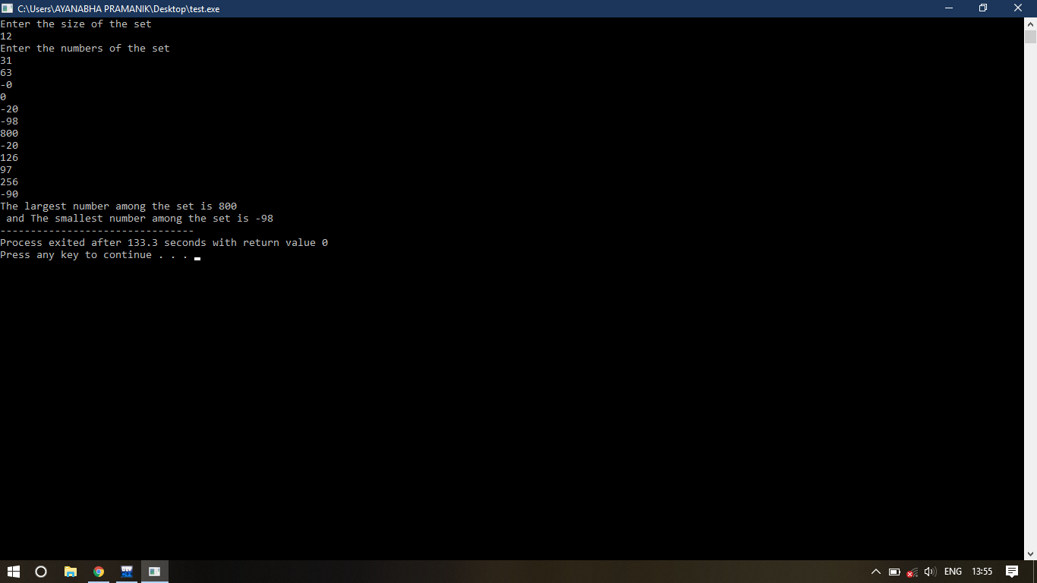

**Chapter-6: More Complex Repetitions**

1. Write a C program to print all prime numbers from 0 to 300.

**PROGRAM**

#include<stdio.h>

int prime(int);

int main()

{

int a=2;

printf("prime numbers from 1 to 300: \n");

while (a<300)

{

if (prime(a)==0)

printf("%d\t",a);

a++;

}

return 0;

}

prime(int a)

{

int c,b=0;

for (c=2;c<a;c++)

{

if (a%c==0)

b++;

}

return b;

}

**OUTPUT**

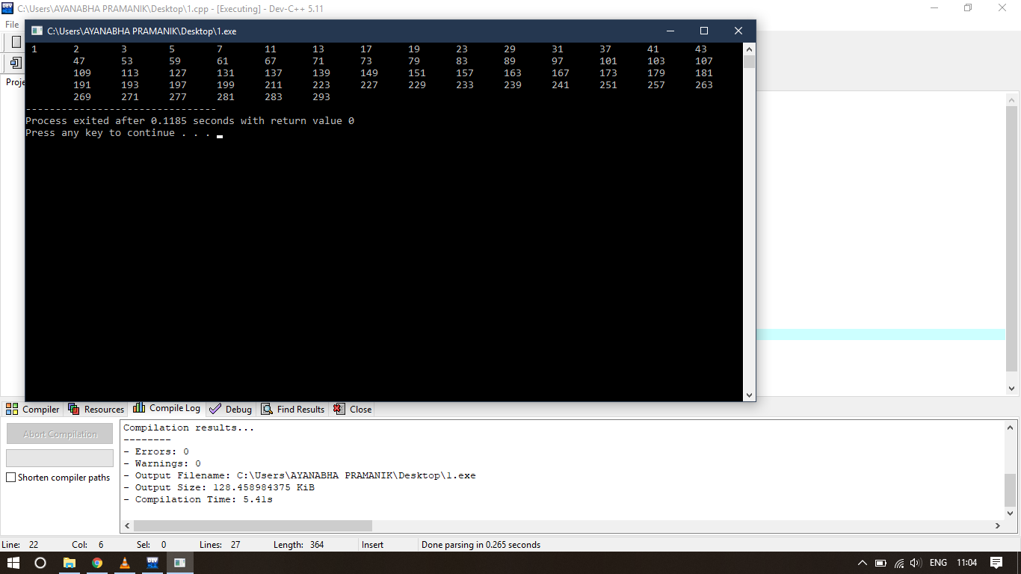

(b) Write a program to add first seven terms of the following series

**PROGRAM**

#include<stdio.h>

float factorial(int);

int main()

{

int a;

float sum=0,div;

printf("Sum of the first even terms of the following series 1/1! + 2/2! + 3/3! + ...\n");

for(a=1;a<=7;a++)

{

div=(a/factorial(a));

sum=sum+div;

}

printf("%f",sum);

return 0;

}

float factorial(int a)

{

int d=a;

int b,c=1;

for (b=1;b<=d;b++)

{

c=c*b;

}

return c;

}

**OUTPUT**

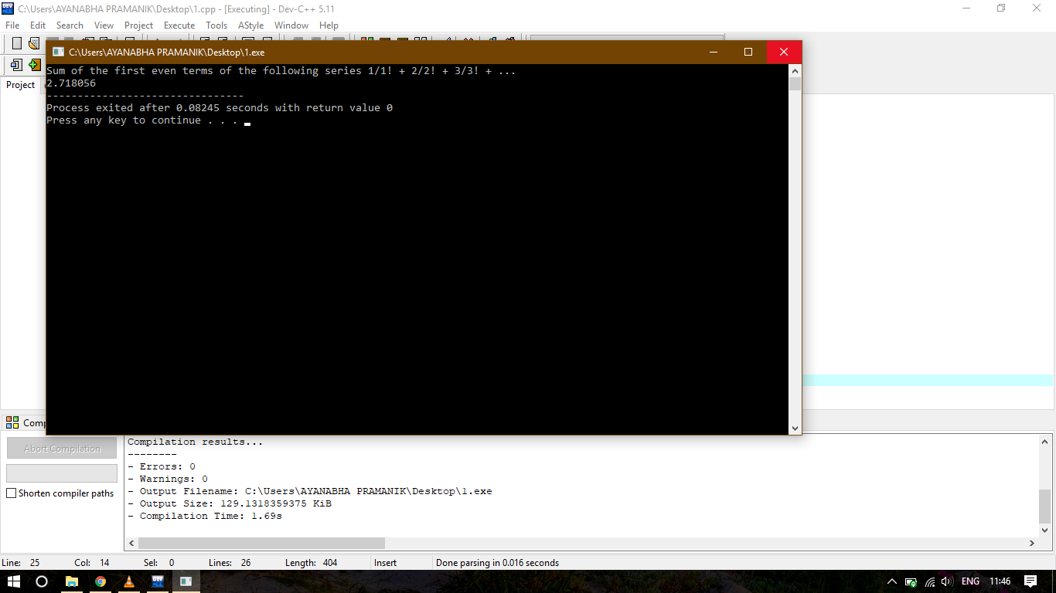

(c) Write a program to generate all combinations of 1,2 and 3 using for loop.

**PROGRAM**

#include<stdio.h>

int main()

{

int first,second,third;

printf("all combinations of 1, 2 and 3 are \n");

for (first=1;first<=3;first++)

{

for (second=1;second<=3;second++)

{

for (third=1;third<=3;third++)

{

printf("%d %d %d \n",first,second,third);

}

}

}

}

**OUTPUT**

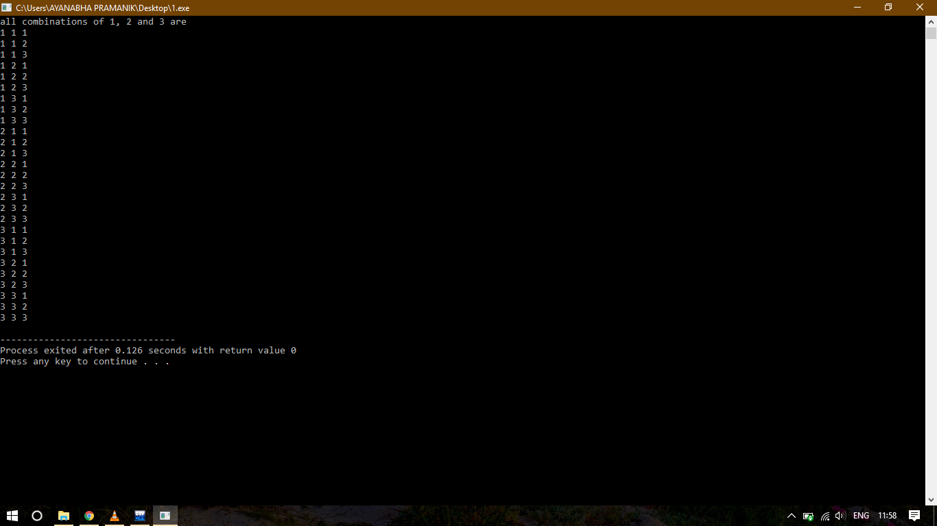

(d) Write a C program to print the multiplication table of the number entered by the user. The table should get display in the following form

29*1 = 29

29*2 = 58 ……

**PROGRAM**

#include<stdio.h>

int main()

{

int i,n;

printf("Enter the number of multiplication table\n");

scanf("%d",&n);

for (i=1;i<=n;i++)

{

printf("29*%d=%d\n",i,(29*i));

}

return 0;

}

**OUTPUT**

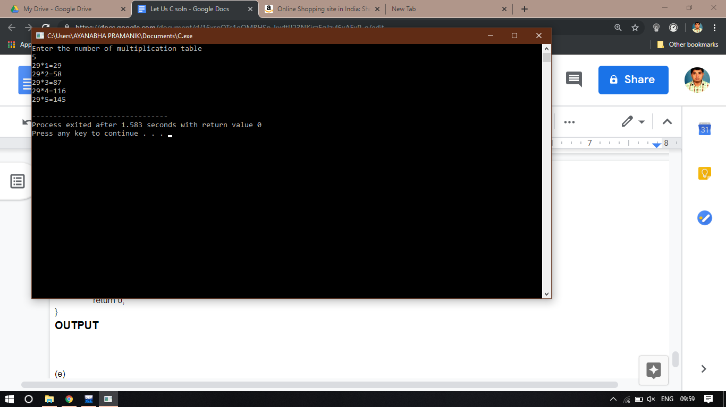

(e) According to a study, the approximate level of intelligence of a person can be calculated using following formula:

i = 2 + ( y + 0.5 x )

Write a program that will produce a table of i, y and x, where y varies from 1 to 6, and, for each value of y, x varies from 5.5 to 12.5 in steps of 0.5.

(f)

(g) The natural logarithm

(h) Write a program to generate all Pythagorean Triplets with side length less than or equal to 30.